Zoe Kosmicki

Assignment 3

Task 4

I started this task by writing out third.s in the nano editor, and then trying to compile and link it. I ran into the error message “third.s:3: Error: unknown psuedo-op: `.shalfword’”. This makes sense, because the compiler doesn’t understand “shalfword”, so I changed it to a: .hword -2.

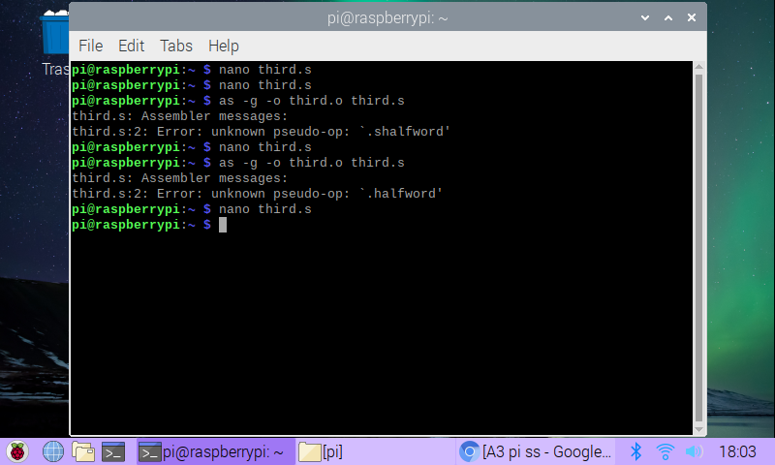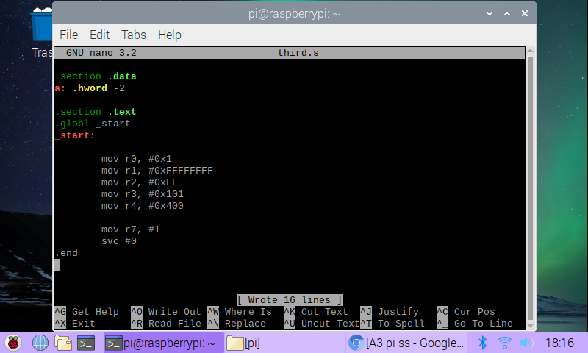I compiled and linked this file with no problems, so I next ran it with the debugger.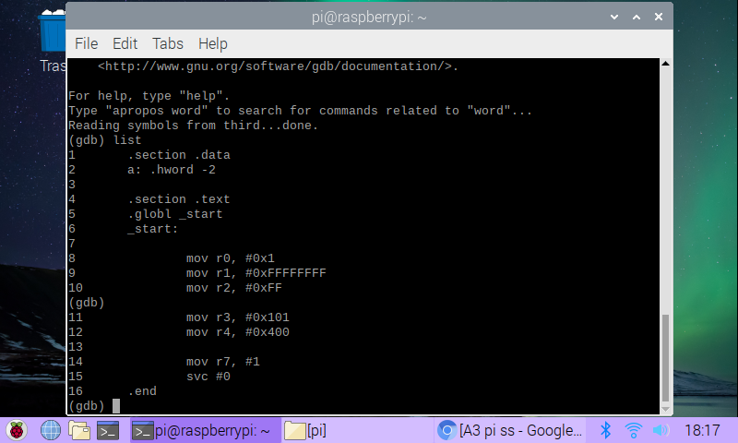I added a breakpoint in at line 8 and ran it. After taking a step, I used the info program instruction to give me the memory address so I could see what was at that address.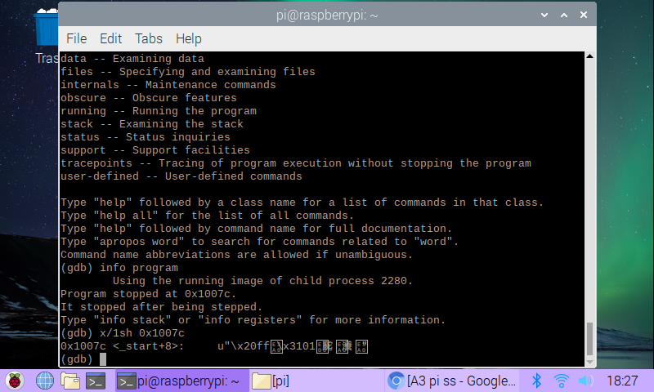As shown above, it gave me the address and offset from the start, along with some indecipherable characters.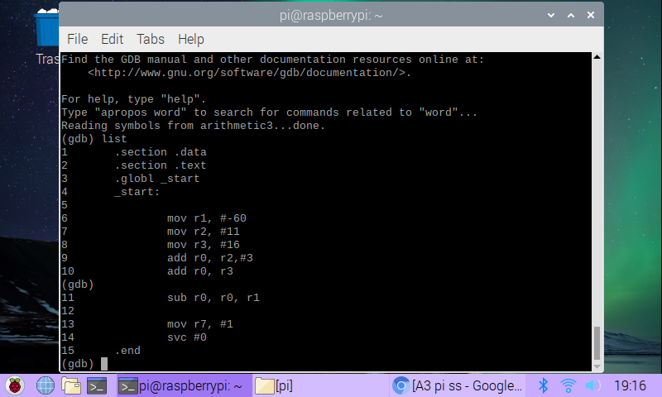Next, I wrote out the arithmetic3.s program in the nano editor, compiled it, linked it, and ran it in the debugger, as shown above.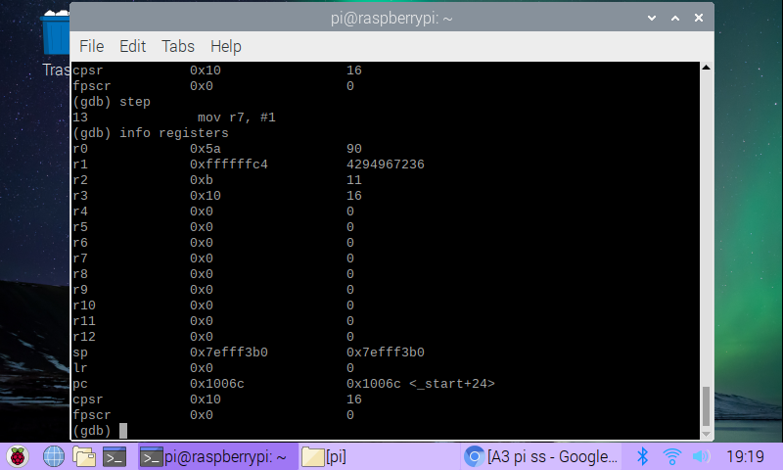I added a breakpoint at line 6 and stepped through the program, checking the registers right before the exit call. In r0, the value 5A is stored, which is the arithmetic evaluation of 11+3+16-(-60). In r1, there’s the 2’s complement of -60, which in hex is FFC4. So in decimal it’s a huge number, but in arithmetic calculations, it’s treated as -60. We can also see that the CPSR register is set to 0x10. This means that the negative flag has been set because we did signed arithmetic.